**Courtney Jensen**

Comprehensive Exam

Answer Revision

**Case Study**

This case study is of a 50 yr old African American woman who has HIV (treated with Reyataz, Norvir, and Truvoda qid, dosage unreported), is sedentary, smokes, and has a history of a substance abuse disorder (history of crack cocaine 5x per month and presently not using). She is 5’4”, 152 lb, with a triglyceride level of 148 mg/dL, total cholesterol of 190 mg/dL, LDL cholesterol of 83 mg/dL, HDL cholesterol of 76 mg/dL, and a blood pressure of 138/80 mmHg. She suffers from seasonal asthma, which is controlled by Ventolin (Albuterol) prn. In 1996, she was diagnosed with Type II diabetes mellitus (DM). She monitors her blood glucose thrice daily with a home blood glucose monitor, and treats her DM with a 15 cc 70/30 Novolog qid. She avoids stair climbing due to mild arthritis in her right knee, which is treated with Advil prn. In November 2011, she fell down a flight of slippery stairs while carrying a few bags to her daughter’s house. Following her fall, she sought treatment from her physician and received a cortisone shot in her right arthritic knee. She was recently referred to Connections Wellness Center in Hartford, CT, to take part in your exercise research study looking at the effects of contingency management (a behavioral change strategy) and physical activity among individuals with HIV who are substance abusers.

Your health/fitness assessment revealed:

RHR: 113 bpm

BP: 126/74 mmHg

BMI: 26.4 kg/m2

Waist circumference: 84.0 cm

Sit and Reach: 29.5 cm

Handgrip Strength: 35 kg (RH: dominant), 35 kg (LH: non-dominant)

Sit-to-Stand Test: 3.66 s (Performed independently without assistance)

YSET: 21.0 ml/kg/min

Please answer the questions below as completely as possible.

What cardiovascular risk factors does she have?

Does she have major signs suggestive of disease? If so, please list.

What risk category is she based on your findings?

Is a medical examination necessary prior to testing and exercise participation? Why?

Is physician clearance needed prior to enrollment into your research study? Why?

Summarize the health/fitness assessment results as they will serve as the basis for the

exercise prescription that you will design for her.

What are her “special conditions/considerations”?

What other healthcare professionals should you consult when designing her exercise prescription?

Formulate her FITT-VP exercise prescription including special considerations.

1. **What cardiovascular risk factors does she have?**

**AGE**

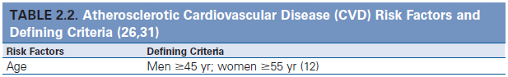

Source: *GETP9, Ch. 2, pg. 27*

Women must be at least 55 years of age to count as a risk factor. The Healthy Activities for Prize Incentives (HAPI) patient is 50 years old. Thus, age is ***not*** a positive cardiovascular disease (CVD) risk factor.

**FAMILY HISTORY**

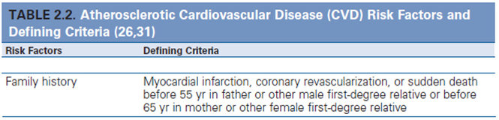

Source: *GETP9, Ch. 2, pg. 27*

In the legend beneath Table 2.2, we are instructed to count risk factors as positive (with the exception of prediabetes unless other criteria are met) if the information was not disclosed or otherwise not available. Family history is not provided by this HAPI patient. Family history is thus counted as a positive risk factor.

**CIGARETTE SMOKING**

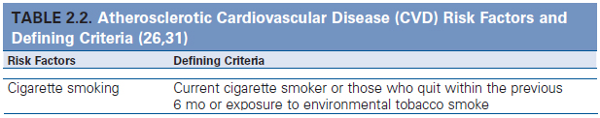

*GETP9, Ch. 2, pg. 27*

The case study indicates she’s a current cigarette smoker. Thus, cigarette smoking counts as a positive risk factor.

**SEDENTARY LIFESTYLE**

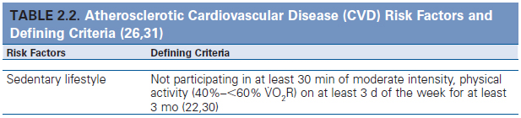

*Source: GETP9, Ch. 4, pg. 66*

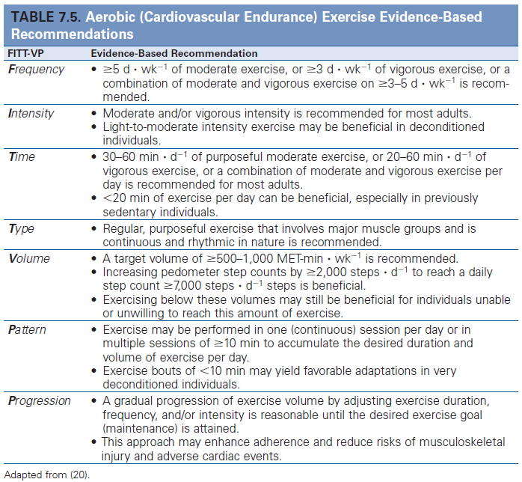

*Source: GETP9, Ch. 7, pg. 180*

For this to count as a positive risk factor, the HAPI patient must fail to meet the American College of Sports Medicine (ACSM) recommendations for participation in moderate physical activity for at least 3 months. This means 40-<60% VO2R for at least 30 minutes a day at least 5 days a week. In the case study, the subject is described as “is sedentary.” Thus, sedentary lifestyle counts as a positive risk factor.

**OBESITY**

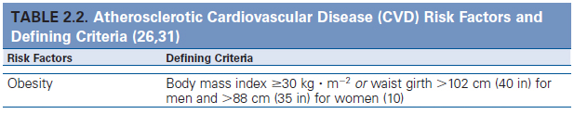

Source: *GETP9, Ch. 2, pg. 27*

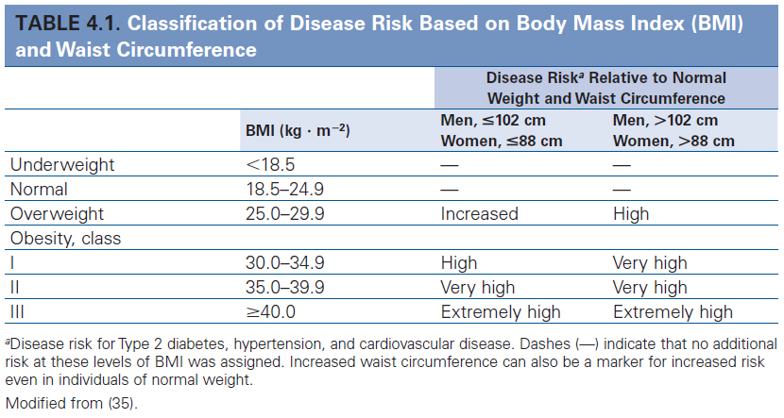

Source: *GETP9, Ch. 4, pg. 63*

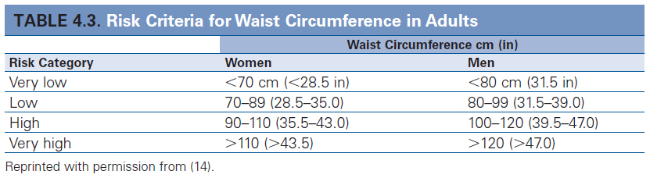

*Source: GETP9, Ch. 4, pg. 66*

For obesity to count as a CVD risk factor, the patient’s body mass index (BMI) must be greater than or equal to 30.0 kg/m2 or have a waist circumference (WC) that exceeds 88 cm (for women). In the case study, she is listed as 5’4”, 152 lb, which equates to a BMI of 26.1 kg/m2. During my assessment (described beneath the case study), her BMI was recorded as 26.4 kg/m2, which means she gained 2 lb between the original assessment and my Health Fitness Research Lab (HFRL) assessment. Assuming she did not change in height, she now weighs 154 lb. Because this is lower than 30.0 kg/m2, she does not meet the criterion for BMI to count as a risk factor. Her WC was not described in the case study, but during my assessment, it was found to be 84.0 cm. Being lower than 88 cm, this does not count as a risk factor either and is considered low risk (see Table 4.3). However, her BMI is considered overweight (25.0 – 29.9 kg/m2; see table 4.1).

**HYPERTENSION**

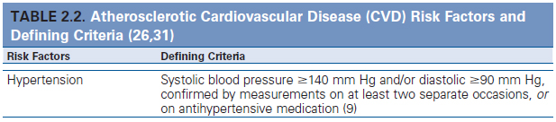

Source: *GETP9, Ch. 2, pg. 27*

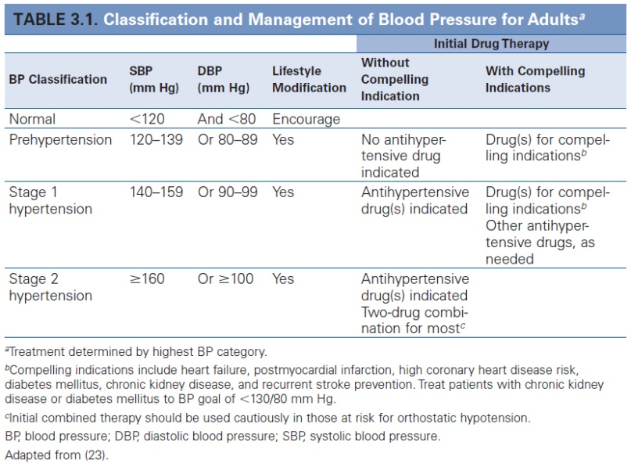

Source: *GETP9, Ch. 3, pg. 46*

For hypertension to be considered a CVD risk factor, the subject must have a stage 1 hypertension diagnosis, confirmed on at least 2 separate occasions or be controlling blood pressure with an antihypertensive medication. Criteria for a stage 1 hypertension diagnosis is systolic blood pressure (SBP) greater than or equal to 140 mmHg and/or diastolic blood pressure (DBP) greater than or equal to 90 mmHg. (If the SBP is greater than or equal to 160 mmHg, or the DBP greater than or equal to 100 mmHg, that meets criteria for diagnosis of stage 2 hypertension.) The HAPI patient’s blood pressure was documented in the case study as 138/80 mmHg. During my HFRL assessment, her BP was recorded as 126/74 mmHg. Neither of these readings meets diagnostic criteria for stage 1 hypertension and thus it is not counted as a positive CVD risk factor. The reason for the reduction in blood pressure (SBP by 12 mmHg, DBP by 6 mmHg) between her initial assessment and the HFRL assessment should be noted, in case the patient forgot to mention a pharmacological treatment, has recently begun exercising, or has altered another behavior that might affect exercise prescription.

**DYSLIPIDEMIA**

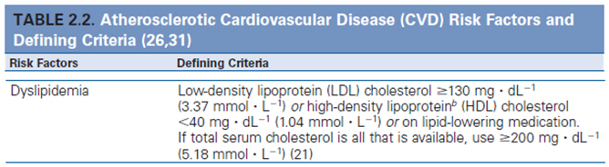

Source: *GETP9, Ch. 2, pg. 27*

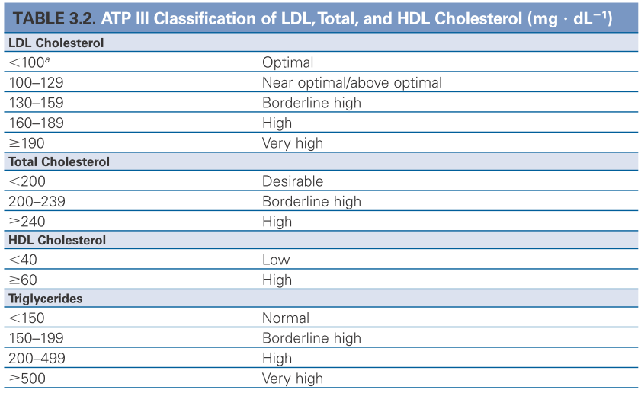

Source: *GETP9, Ch. 4, pg. 48*

For dyslipidemia to count as a CVD risk factor, low-density lipoprotein (LDL) cholesterol must be greater than or equal to 130 mg/dL or high-density lipoprotein (HDL) cholesterol be lower than 40 mg/dL or be on lipid lowering medication. If total serum cholesterol is all that is available, a reading greater than or equal to 200 mg/dL suffices to constitute a positive CVD risk factor. The subject has a triglyceride level of 148 mg/dL (“normal” according to the ATP III classification found in Table 3.2 of GETP9), total cholesterol of 190 mg/dL (“borderline high”), LDL cholesterol of 83 mg/dL (“optimal”), and HDL cholesterol of 76 mg/dL (“high”). Lipids-lipoproteins thus do not constitute a positive CVD risk factor.

**PREDIABETES**

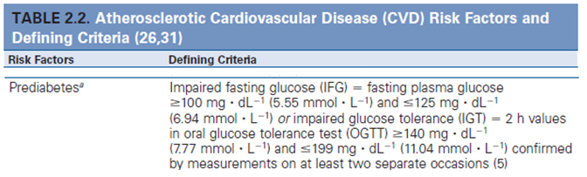

Source: *GETP9, Ch. 2, pg. 27*

For this to count as a positive CVD risk factor, the subject must have a fasting plasma glucose of greater than or equal to 100 mg/dL, but less than 126 mg/dL. If this isn’t met, but the subject has impaired glucose tolerance, marked by a 2-hour value in the oral glucose tolerance test of greater than or equal to 140 mg/dL of glucose (though less than 200 mg/dL), then this counts as a CVD risk factor as well. I don’t have the subject’s glucose measurements, I do have confirmation that she has a positive diagnosis of type II diabetes mellitus (DM), and is treating it with a 15 cc 70/30 Novolog qid. This is not counted as a CVD risk factor, but a known metabolic disease (see Figure 2.3).

**NEGATIVE RISK FACTOR**

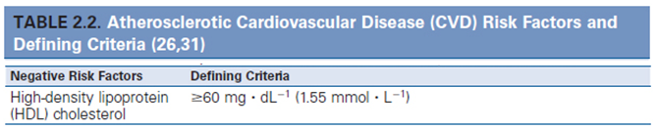

Source: *GETP9, Ch. 2, pg. 27*

The HAPI patient’s HDL cholesterol is 76 mg/dL (“high” according to ATP III classification in Table 3.2; see previous page). If HDL cholesterol is above 60 mg/dL, then it counts as a negative risk factor and one point is removed from the gross sum. The HDL cholesterol recorded in this patient counts as a negative CVD risk factor.

**SUMMARY OF CVD RISK FACTORS**

The subject has a gross sum of 3 positive CVD risk factors: an implied family history (not stated), cigarette smoking, and sedentary lifestyle. However, she has one negative risk factor (HDL above 60 mg/dL). Thus, the net sum of risk factors is 3. I’ve represented this in the table seen below

|  |  |  |
| --- | --- | --- |
| **CVD risk factors** | **Case study** | **Results** |
| **Age:** men ≥45 yr; women ≥55 yr | Woman, 50 yr | No |
| **Family history:** myocardial infarction, coronary revascularization, or sudden death before 55 yr in father or other male first-degree relative or before 65 yr in mother or other female first-degree relative | Not described/unknown | Positive risk |
| **Cigarette smoking**: current cigarette smoker or quit within the previous 6 mo or exposure to environmental tobacco smoke | Described as a smoker | Positive risk |
| **Sedentary lifestyle**: not participating in at least 30 min of moderate intensity, physical activity (40-60VO2R) on at least 3d/wk for at least 3 months | Described as sedentary | Positive risk |
| **Obesity**: BMI is ≥30 kg/m2 or WC is greater than 88cm (among women) | BMI ranges from 26.1 kg/m2 to 26.4 kg/m2, WC is 84 cm | No |
| **Hypertension:** SBP ≥140 mmHg and/or DBP ≥ 90 mmHg or on antihypertensive medication | Blood pressure ranges from 126/74 to 138/80 mmHg | No |
| **Dyslipidemia:** LDL cholesterol ≥ 130mg/dL or HDL cholesterol < 40mg/dL or on lipid-lowering medication, or if total cholesterol is all that is available, ≥200 mg/dL total cholesterol | Triglycerides: 148 mg/dL,  HDL: 76 mg/dL,  LDL: 83 mg/dL,  Total cholesterol: 190 mg/dL | No |
| **Prediabetes:** fasting plasma glucose ≥ 100 mg/dL but ≤ 125 mg/dL, or 2 h values in oral glucose tolerance test ≥ 140 mg/dL but ≤ 199 mg/dL, confirmed on at least 2 occasions | Diagnosed with type II diabetes mellitus in 1996. Metabolic disease, not a risk factor. | No |
| **Negative Risk factors** |  | |
| HDL cholesterol ≥ 60 mg/dL | HDL: 76 mg/dL | Negative risk |

**OTHER FITNESS VARIABLES ASSESSED**

**Resting heart rate (RHR): 113 bpm**

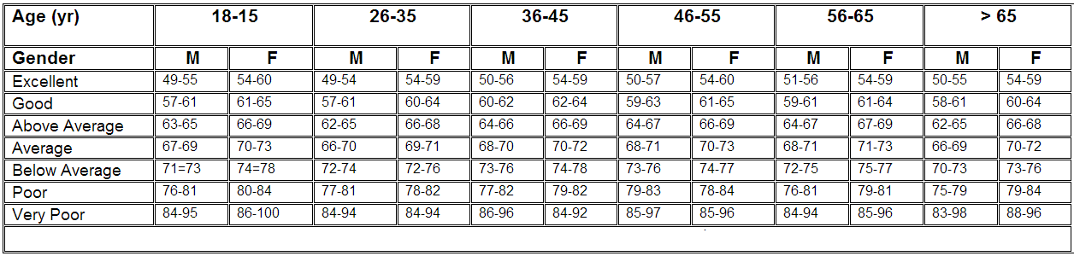

Source: *Golding, Myers, Sinning. (1989). Y’s Way to Physical Fitness: The Complete Guide to Fitness Testing and Instruction. Published for YMCA of the USA by Human Kinetics Publishers, Champaign, IL.*

Her RHR of 113 bpm is considered “Very Poor” according to Golding et al. (1989).

**Sit-and-reach: 29.5 cm**

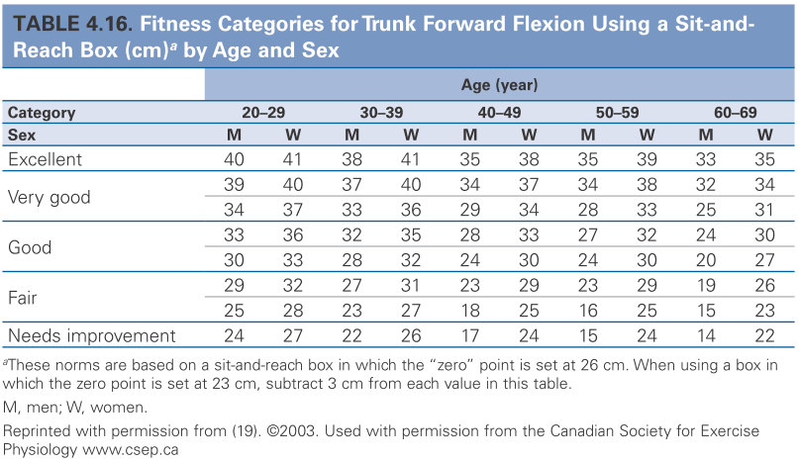

Source: *GETP9, Ch. 4, pg. 107*

Her sit-and-reach distance of 29.5 cm is considered “Very good” according to *GETP9*.

**Handgrip Strength: 35 kg (RH: dominant), 35 kg (LH: non-dominant)**

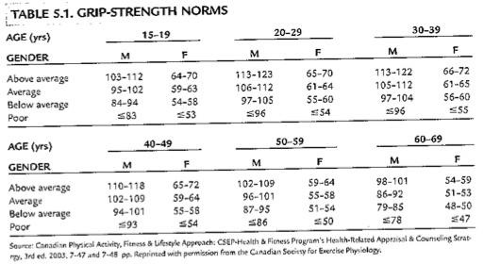

Source: *Canadian Physical Activity, Fitness & Lifestyle Approach: CSEP-Health  
& Fitness Program's Health-Related Appraisal & Counseling Strategy,  
3rd ed. 2003.*

Her grip strength of 70 kg (combined hands) is “Above average” according to the 3rd edition of the *Canadian Physical Activity, Fitness & Lifestyle* *Approach* manual.

**Sit-to-Stand Test: 3.66 s (Performed independently without assistance)**

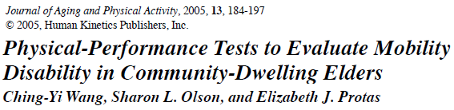

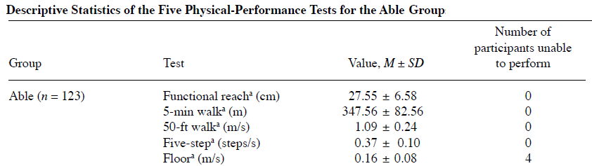

The HAPI patient’s sit-to-stand performance of 3.66 s equates to 0.44 meters per second. This exceeds the mean performance found among able-bodied elders in Wang et al., 2005.

**YSET: 21.0 ml/kg/min**

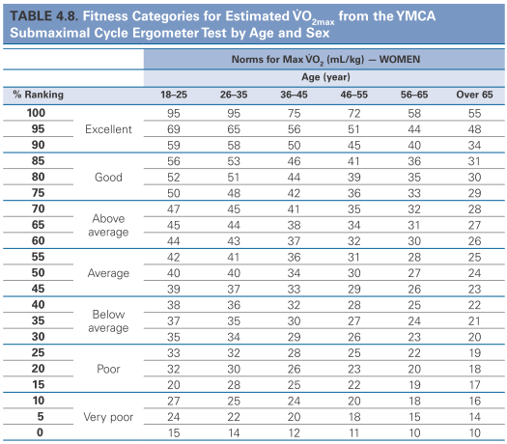

Source: *GETP9, Ch. 4, pg. 84*

A YMCA cycle ergometer test result of 21.0 ml/kg/min is considered to be between “poor” and   
very poor” for a 50 year old woman.

**SUMMARY OF OTHER FITNESS VARIABLES**

|  |  |  |
| --- | --- | --- |
| **VARIABLE** | **SCORE** | **CLASSIFICATION** |
| Resting heart rate | 113 bpm | Very poor |
| Sit-and-reach | 29.5 cm | Very good |
| Handgrip strength | 70 kg | Above average |
| Floor transfer test | 3.66 s | Better than comparison population |
| YMCA Cycle Ergometer test | 21.0 ml/kg/min | Between poor and very poor |

1. **Does she have major signs suggestive of disease? If so, please list.**

In the case study, the HAPI patient is not described as having signs or symptoms suggestive of disease (*GETP9, Figure 2.3, ch. 2, pg. 26*):

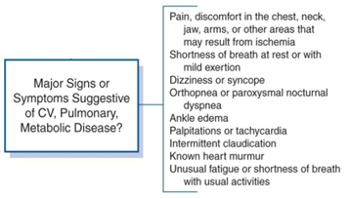

However, she does have human immunodeficiency virus (HIV). On page 293 (GETP9, ch. 10), discussing HIV and antiretroviral therapy (ART), it states:

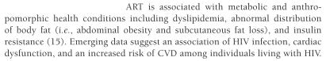

Moreover, she was diagnosed with type 2 DM in 1996. Ignoring all other variables, this alone would classify her as high risk before reaching the suggestive “signs or symptoms” portion of the logic model (*GETP9, Figure 2.3, ch. 2, pg. 26*). Lastly, if she were not HIV positive and did not have a diagnosis of type 2 DM, her asthma (for which she uses an Albuterol inhaler) is a known pulmonary disease, which would automatically shift her stratification to high risk.

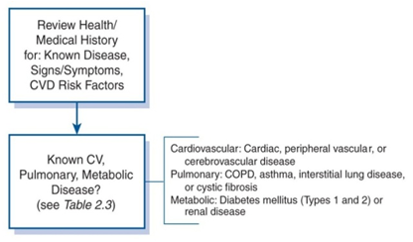

1. **What risk category is she based on your findings?**

The HAPI patient would be classified as high risk. Below is Figure 2.3 illustrating the criteria for classification:

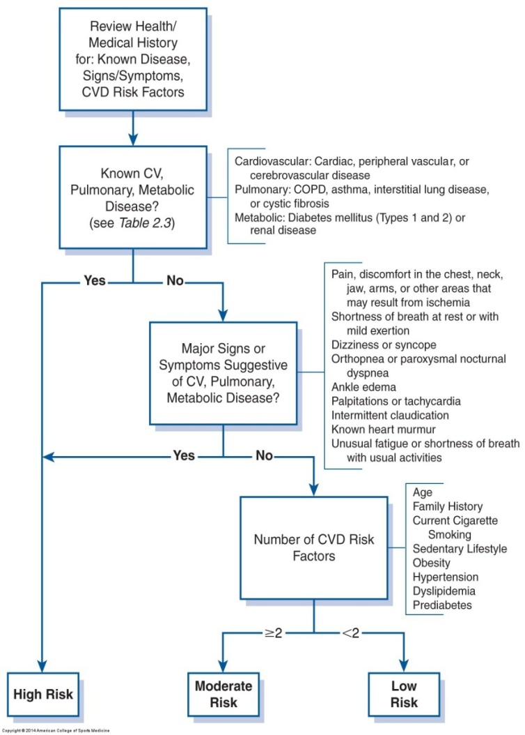

**FIGURE 2.3.Logic model for classification of risk.** *GETP9, ch. 2, pg. 26*

1. **Is a medical examination necessary prior to testing and exercise participation? Why?**

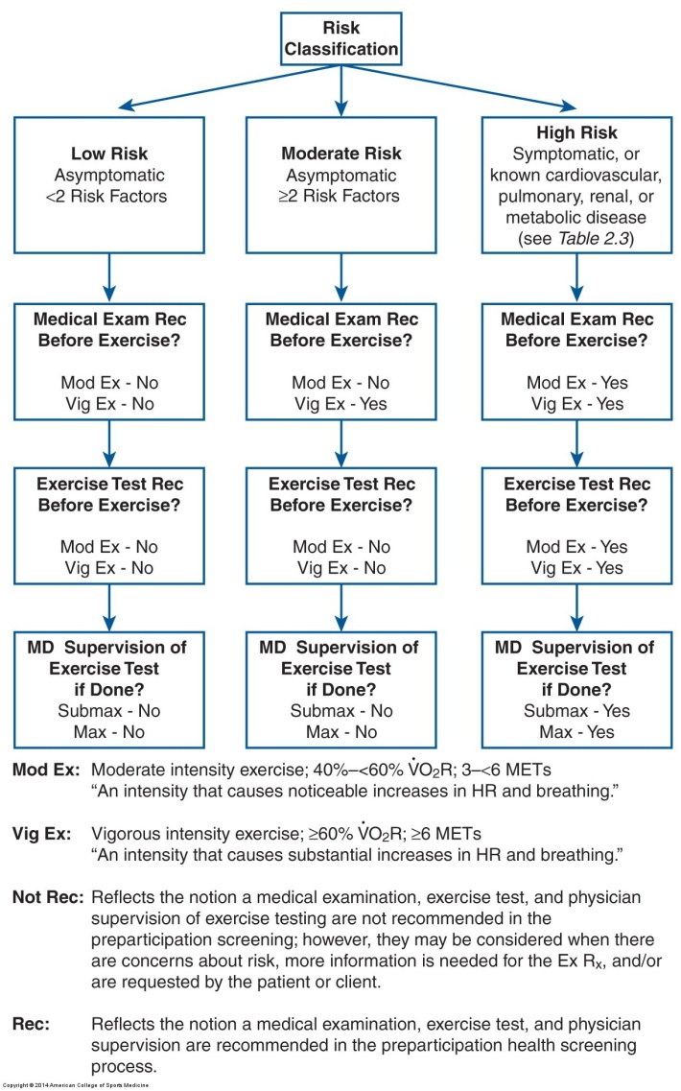

**FIGURE 2.4. Medical examination, exercise testing, and supervision of exercise testing**

**pre-participation recommendations based on classification of risk.**

After reviewing the patient’s risk factors, signs and symptoms of disease, and known diseases, she is classified as high risk. As such, a medical examination is necessary prior to both moderate and vigorous exercise participation. Although adherence to the ACSM guidelines will help minimize risks associated with the initiation of an exercise program, CVD risk factors can be aggravated by acute exercise. This can be especially pronounced (and thus dangerous) among patients who were previously sedentary who have just initiated an exercise program (Cobb & Weaver, 1986, JACC, 7: 215-219). Because this HAPI patient will be transitioning from a sedentary lifestyle, she may be predisposed to an elevated risk of cardiovascular events. A medical examination will help ensure her safety. This point is echoed on page 31 of *GETP9*:



The information gathered during the medical exam may also be useful for the subsequent establishing of an ExRx (*GETP9*, pg. 32)

1. **Is physician clearance needed prior to enrollment into your research study? Why?**

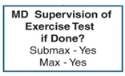

Depending on randomization, enrollment in the study involves consistent participation in an exercise program. The Surgeon Generals’ Report on Physical Activity and Health (1996) states: “[P]reviously inactive men over age 40 and women over age 50, and people at high risk for cardiovascular disease (CVD) should first consult a physician before embarking on a program of vigorously physical activity to which they are unaccustomed.” While the activity would not be “vigorously physical” (rather, moderate), the subject is a 50 year old woman who is unaccustomed to physical activity and has known metabolic and pulmonary diseases in addition to diagnoses of HIV and substance use disorder. The transition from a sedentary lifestyle to one marked by routine exercise and physical activity poses threats. One reason for having physician supervision and clearance prior to enrollment in the study is liability (*GETP9*, pg. 33):



1. **Summarize the health/fitness assessment results as they will serve as the basis for the exercise prescription that you will design for her.**

I will provide the summary tables from pages 8 and 11 of this paper. First, the table illustrating performance classifications on variables that are not criteria for CVD risk stratification:

|  |  |  |
| --- | --- | --- |
| **VARIABLE** | **SCORE** | **CLASSIFICATION** |
| Resting heart rate | 113 bpm | Very poor |
| Sit-and-reach | 29.5 cm | Very good |
| Handgrip strength | 70 kg | Above average |
| Floor transfer test | 3.66 s | Better than comparison population |
| YMCA Cycle Ergometer test | 21.0 ml/kg/min | Between poor and very poor |

Secondly, the table that summarizes the HAPI patient’s CVD risk factors:

|  |  |  |
| --- | --- | --- |
| **CVD risk factors** | **Case study** | **Results** |
| **Age:** men ≥45 yr; women ≥55 yr | Woman, 50 yr | No |
| **Family history:** myocardial infarction, coronary revascularization, or sudden death before 55 yr in father or other male first-degree relative or before 65 yr in mother or other female first-degree relative | Not described/unknown | Positive risk |
| **Cigarette smoking**: current cigarette smoker or quit within the previous 6 mo or exposure to environmental tobacco smoke | Described as a smoker | Positive risk |
| **Sedentary lifestyle**: not participating in at least 30 min of moderate intensity, physical activity (40-60VO2R) on at least 3d/wk for at least 3 months | Described as sedentary | Positive risk |
| **Obesity**: BMI is ≥30 kg/m2 or WC is greater than 88cm (among women) | BMI ranges from 26.1 kg/m2 to 26.4 kg/m2, WC is 84 cm | No |
| **Hypertension:** SBP ≥140 mmHg and/or DBP ≥ 90 mmHg or on antihypertensive medication | Blood pressure ranges from 126/74 to 138/80 mmHg | No |
| **Dyslipidemia:** LDL cholesterol ≥ 130mg/dL or HDL cholesterol < 40mg/dL or on lipid-lowering medication, or if total cholesterol is all that is available, ≥200 mg/dL total cholesterol | Triglycerides: 148 mg/dL,  HDL: 76 mg/dL,  LDL: 83 mg/dL,  Total cholesterol: 190 mg/dL | No |
| **Prediabetes:** fasting plasma glucose ≥ 100 mg/dL but ≤ 125 mg/dL, or 2 h values in oral glucose tolerance test ≥ 140 mg/dL but ≤ 199 mg/dL, confirmed on at least 2 occasions | Diagnosed with type II diabetes mellitus in 1996. Metabolic disease, not a risk factor. | No |
| **Negative Risk factors** |  | |
| HDL cholesterol ≥ 60 mg/dL | HDL: 76 mg/dL | Negative risk |

1. **What are her “special conditions/considerations”?**

The special conditions and considerations will be described in several sections. First I will reproduce the relevant special considerations for exercise prescription that appear in GETP9. Secondly, I will describe the special conditions (e.g., arthritis) outlined in the case study. Lastly, I will provide an overview of her pharmacological profile, including the classes of drugs she’s taking, the any notable drug interactions, and common and serious side effects.

First and foremost, the HAPI patient has a diagnosis of HIV. The special considerations for exercise ***testing*** among people with HIV/AIDS (*GETP9*, ch. 10, pg. 293-294) are as follows:

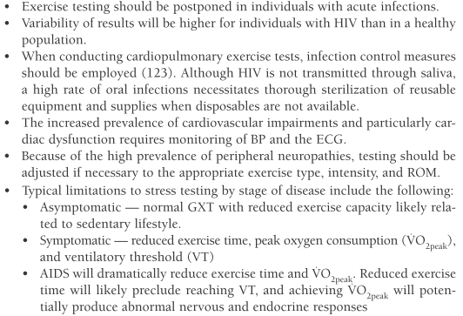

The special considerations for exercise ***prescription*** among people with HIV/AIDS (*GETP9*, ch. 10, pg. 295) are as follows:

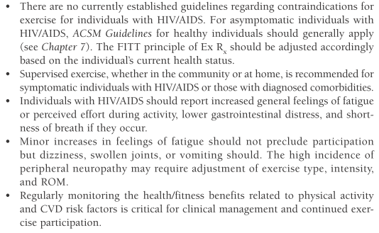

It should be noted that the patient also has a diagnosis of type 2 DM. Type 2 DM is characterized by hyperglycemia due to impaired insulin function. If the hyperglycemic state is sustained, vascular diseases and neuropathies can result. Exercise (in addition to diet and medication) is a component of the treatment plan. There are special considerations in both exercise testing and exercise prescription among people with DM. Special considerations for DM are described in *GETP9* on pages 278-284. While this section is extensive, I’ve summarized some of the major points (not all directly related to the HAPI patient, but to patients with DM in general):

**Considerations in exercise testing:**

* Exercise testing might not be necessary if using light-to-moderate intensity, providing the subject is currently asymptomatic for CVD and has a risk of less than 10% for experiencing a cardiac event within the next 10 years.
* If the subject’s risk of experiencing a cardiac event in the next 10 years is ≥ 10%, a medically supervised graded exercise test with ECG should be conducted prior to engaging in vigorous activity.
* If any abnormal test results were documented in the ECG, follow-up testing is advised.
* Annual assessment of CVD risk factors should be conducted due to the silent ischemia that frequently goes undetected in patients with DM.

**Considerations in exercise prescription:**

* Regular exercise can result in improvements to glucose tolerance, increases in insulin sensitivity, and reductions to HbA1C. If the subject is using insulin, exercise may reduce reliance on exogenous insulin.
* Regular exercise may mitigate the increased risk of CVD commonly experienced by people with DM (reduce bodyweight and BP, improve lipid profile, etc.).

Regarding contraindications to exercise (as described in Box 3.5 on page 53 of *GETP9*; provided on the next page), the HAPI patient exhibits no absolute contraindications to exercise testing. As can be seen in the penultimate relative risk, the patient’s HIV status is considered a relative risk: “Chronic infectious disease (e.g., HIV).”

Secondly, if her arthritis is exacerbated by exercise, this becomes a relative contraindication as well: “neuromuscular, musculoskeletal, or rheumatoid disorders that are exacerbated by exercise.”

Among patients with HIV, arthritis (particularly in the knees, where this patient experiences it), is common. The glycoproteins contained in the viral envelope of the HIV particle have been shown to promote arthritis, with 51% of these cases occurring in the knees (Klatt, 2012). It may therefore be questioned whether this subject’s arthritis is HIV-related, making the close monitoring of her HIV even more important.

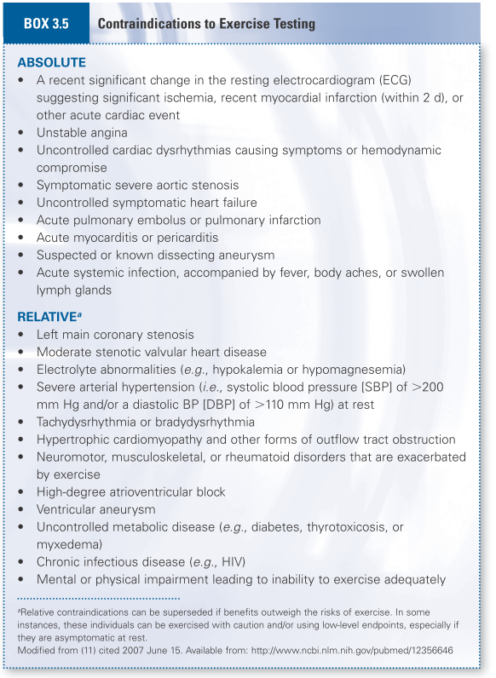

Although the patient’s DM is currently well-controlled, if it goes uncontrolled, this would count as a relative contraindication as well: “Uncontrolled metabolic disease (e.g., diabetes, thyrotoxicosis, or myxedema).”

Additionally, in November 2011, the patient fell down a flight of stairs, which resulted in pain or injury enough to warrant a cortisone shot. I will regard this as a possible relative contraindication (“Mental or physical impairment leading to inability exercise adequately”) as it may impair the ability to do activities that involve her knee (e.g., stepmill exercise machine).

Regarding her medical profile, 7 pharmacological agents were listed: Cortisone, Advil, Novolog, Ventolin, Truvada, Norvir, and Reyataz. I will characterize each.

**Reyataz (atazanavir)** is a member of the following classes:

Antiretroviral Agent  
Antiviral  
Protease Inhibitor

Among the notable drug interactions, concurrent use of atazanavir and statins elicit a range of effects. Although this patient isn’t currently taking a statin, it’s worth an awareness of the interaction. Contraindicated drug interactions exist with Simvastatin and Lovastatin, both of which may increase the risk of statin toxicity, including increased risk of myopathy and/or rhabdomyolysis.

Atazanavir with other statins (Rosuvastatin and Atorvastatin) exhibit similar but less pronounced effects and are only considered major interactions. Pitavastatin is considered a moderate interaction, which, when interacting with atazanavir, may result in increased plasma concentration of the statin.

The case study does not state that the patient is on methadone, but many people with substance use disorder do take methadone and there is a moderate interaction listed between Reyataz and methadone, which may induce an increased risk of QT interval prolongation and potential ventricular tachycardia.

Also, being a woman who is 50, it’s unlikely that she’s on contraceptives, but possible. In the U.S., the average age at the onset of menopause is between 40 and 61 (Minkin, Mary Jane; et al. (1997). What Every Woman Needs to Know about Menopause. Yale University Press. ISBN 0-300-07261-9.) However, among women with HIV who use highly active antiretroviral therapy (HAART), menopause typically occurs earlier in life. Among African American women who have HIV and use HAART, the mean age is 49 yr (Kojic, Wang, & Cu-vin, 2007, “HIV and menopause: a review”, J Womens health, 16(10): 1402-14011).

Concomitant use of atazanavir and certain oral contraceptives has resulted in marked increases in progesterone exposure. Long-term effects of such exposure are not known, but may result in an increased risk of insulin resistance and dyslipidemia.

The common adverse effects listed for atazanavir are:

Cardiovascular: Peripheral edema

Dermatologic: Rash (20% to 21%)

Gastrointestinal: Abdominal pain (20% ), Diarrhea (15% to 30%), Nausea (20% ), Vomiting

Hepatic: Unconjugated hyperbilirubinemia, Asymptomatic

Neurologic: Headache (25%)

Respiratory: Cough

Other: Fever

The serious adverse effects listed for atazanavir are:

Cardiovascular: Atrioventricular block, Prolonged PR interval, Prolonged QT interval (rare), Torsades de pointes

Dermatologic: Erythema multiforme, Stevens-Johnson syndrome

Endocrine metabolic: Lactic acidosis

Hepatic: Jaundice

Immunologic: Drug hypersensitivity syndrome, Immune reconstitution syndrome

Renal: Urolithiasis

**Norvir (ritonavir)** is a member of the following classes:

Antiretroviral Agent  
Protease Inhibitor

The drug interactions of ritonavir are very similar to atazanavir. There are contraindicated interactions with Simvastatin and Lovastatin, a major interaction with Pitavastatin, and moderate interactions with Rosuvastatin, methadone, and some oral contraceptives.

Additionally, there is a contraindicated interaction with St. John’s Wort, which concurrent use may decrease the plasma concentration of ritonavir. Although St. John’s Wort was not listed in the medications provided by the case study, people often take vitamins, minerals, and herbal supplements without documenting it in a pharmaceutical log, so there is a possibility she could be taking it. Likewise, there is a major interaction with protease inhibitors such as ritonavir with garlic, which can decrease the plasma concentration of the protease inhibitor as well as increase the risk of antiretroviral resistance and subsequent treatment failure.

Another major interaction with ritonavir is with oxycodone. Although this patient did not list oxycodone, it is a common drug used recreationally and she does have substance use disorder. Ritonavir may decrease oxycodone clearance and increase its plasma concentrations.

The common adverse effects are:

Endocrine metabolic: Serum cholesterol raised (30.7% to 65.2% )

Gastrointestinal: Abdominal pain (2.1% to 8.3% ), Diarrhea (2% to 25% ), Loss of appetite (1.7% to 8.6% ), Nausea (18.4% to 46.6% ), Taste sense altered (5% to 17.2% ), Vomiting (2% to 23.3% )

Neurologic: Asthenia (10.3% to 28.4% ), Circumoral paresthesia (3.4% to 6.7% ), Paresthesia, Peripheral (up to 6% )

The serious adverse effects are:

Cardiovascular: Atrioventricular block, Prolonged PR interval, Right bundle branch block, Syncope (0.9% to 2.1% )

Dermatologic: Erythema multiforme (less than 2% ), Erythroderma (less than 2% ), Stevens-Johnson syndrome, Toxic epidermal necrolysis due to drug

Endocrine metabolic: Diabetes mellitus (less than 2% ), Hyperglycemia

Gastrointestinal: Pancreatitis (less than 2% )

Hepatic: Hepatitis (less than 2% ), Hepatotoxicity, Increased liver function test, Jaundice (less than 2% )

Immunologic: Immune hypersensitivity reaction

Renal: Acute renal failure (less than 2% ), Nephrotoxicity (less than 2% )

**Truvada (Emtricitabine/Tenofovir Disoproxil Fumarate)** is an Antiretroviral Agent

There are two notable drug interactions with tenofovir. One is with the first antiretroviral listed (atazanavir, major interaction) and the other is with the second (ritonavir, moderate interaction).

When Truvada is used concurrently with atazanivir, the atazanivir concentrations may decrease and/or the tenofovir concentration may increase. This can result in renal disorders if not monitored closely. It may help mitigate these problems if atazanavir and ritonavir are coadministered with tenofovir, but the patient still needs to be closely monitored. Likewise, if ritonavir and tenofovir are used concurrently without atazanivir, there may be an increase in tenofovir bioavailability, by which bone integrity, renal function, and hepatic function must be monitored.

Common adverse effects of tenofovir administration are:

Dermatologic: Rash (10% or greater )

Endocrine metabolic: Lactic acidosis

Gastrointestinal: Abdominal pain (HIV-1 infected patients, 5% or greater; HIV-1 uninfected subjects, 4% ), Diarrhea (9% ), Nausea (9% ), Serum amylase raised (8% )

Musculoskeletal: Backache (5% or greater ), Myalgia (5% or greater ), Osteopenia

Neurologic: Dizziness (8% ), Headache (HIV-1 infected patients, 6%; uninfected subjects, 7% ), Insomnia (10% or greater ), Peripheral neuropathy (5% or greater )

Psychiatric: Depression (9% ), Dream disorder (10% or greater )

Respiratory: Pneumonia (5% or greater )

Other: Fatigue (9%

Serious adverse effects of tenofovir administration are:

Gastrointestinal: Pancreatitis

Hepatic: Hepatomegaly, with steatosis, Hepatotoxicity, Relapsing type B viral hepatitis

Immunologic: Immune reconstitution syndrome

Musculoskeletal: Rhabdomyolysis

Renal: Fanconi syndrome, Renal failure, Renal impairment

**Ventolin (Albuterol sulfate)** is a member of the following drug classes:

Beta-2 Adrenergic Agonist  
Bronchodilator  
Cardiovascular Agent  
Sympathomimetic

There is one drug interaction which doesn’t appear to apply to this patient, but is worth noting. Concurrent use of beta-adrenergic blockers and beta-2 agonists are listed as a major interaction, the result of which may decrease the effectiveness of either agent.

Common adverse effects:

Cardiovascular: Tachyarrhythmia

Endocrine metabolic: Hypokalemia

Gastrointestinal: Nausea (10% ), Pharyngitis (14% ), Throat irritation (10% )

Neurologic: Feeling nervous (7% ), Headache (7% ), Tremor (7% )

Respiratory: Cough (5% ), Rhinitis (5% to 16% ), Upper respiratory infection (21% ), Viral lower respiratory infection (7% )

Serious adverse effects:

Cardiovascular: Atrial fibrillation, Myocardial infarction

Endocrine metabolic: Diabetic ketoacidosis

Respiratory: Pulmonary edema

**Novolog** is a member of the following drug classes:

Antidiabetic  
Insulin, Ultra Rapid Acting

There is one major drug interaction worth noting: concurrent use of antidiabetic agents such as Novolog and beta-adrenergic blockers can result in hypoglycemia, hyperglycemia, or hypertension.

There are moderate interactions listed with guar gum and insulin (increased risk of hypoglycemia), aspirin and insulin (hypoglycemia, CNS depression, and seizures), and antidiabetic agents and eucalyptus (increased risk of hypoglycemia).

Common adverse effects:

Dermatologic: Injection site reaction, Transient

Endocrine metabolic: Hypoglycemia (27% to 75% ), Lipodystrophy

Serious adverse effects:

Endocrine metabolic: Hypoglycemia (Severe), Hypokalemia

Immunologic: Anaphylaxis

**Advil (ibuprofen)** is a member of the following drug classes:

Analgesic  
Antimigraine  
Antirheumatic  
Central Nervous System Agent  
Musculoskeletal Agent  
NSAID  
Propionic Acid (class)

There is a major drug interaction with NSAIDs and ginko, which may increase the risk of bleeding. There is a moderate drug interaction between NSAIDs and ACE inhibitors (as well as beta-andrenergic blockers), which may result in a decrease of the antihypertensive efficacy. There is a moderate interaction between ibuprofen and aspirin, which may decrease the antiplatelet effect of aspirin.

Common adverse effects:

Cardiovascular: Hypotension (intravenous, up to 10% )

Dermatologic: Rash (oral, 3% to 9% )

Endocrine metabolic: Hypernatremia (intravenous, up to 10% ), Hypoalbuminemia (intravenous, 3% to 10% ), Hypoproteinemia (intravenous, up to 13% ), Serum lactate dehydrogenase level elevated (intravenous, 3% to 10% )

Gastrointestinal: Flatulence (injection, 7% to 16% ), Heartburn (oral, 3% to 9% ), Nausea (oral, 3% to 9%; intravenous, 53% to 57% ), Vomiting (oral, 1% to 3%; intravenous, 15% to 22% )

Hematologic: Thrombocytosis (intravenous, 3% to 10% )

Immunologic: Bacteremia (injection, 13% )

Neurologic: Dizziness (oral, 3% to 9%; intravenous 4% to 6% ), Headache (oral, 1% to 3%; intravenous, 9% to 11% )

Renal: Serum blood urea nitrogen raised (intravenous, up to 10% ), Urinary retention (intravenous, 3% to 5% )

Respiratory: Bacterial pneumonia (intravenous, 3% to 10% )

Serious adverse effects:

Cardiovascular: Congestive heart failure (oral, less than 1%), Hypertension (oral, less than 1%; intravenous, up to 10% ), Myocardial infarction, Thrombotic tendency observations

Dermatologic: Erythema multiforme (oral, less than 1% .), Erythroderma, Stevens-Johnson syndrome (oral, less than 1% ), Toxic epidermal necrolysis

Gastrointestinal: Gastrointestinal hemorrhage (oral, less than 1% ), Gastrointestinal perforation (oral, less than 1% ), Gastrointestinal ulcer, Inflammatory disorder of digestive tract, Melena (oral, less than 1% ), Pancreatitis (oral, less than 1% )

Hematologic: Agranulocytosis (oral, less than 1% ), Anemia (intravenous, 2% to 36% ), Aplastic anemia (oral, less than 1% ), Bleeding (intravenous, 4% to 10% ), Hemolytic anemia (oral, less than 1% ), Neutropenia (intravenous, 7% to 13%; oral, less than 1% ), Thrombocytopenia (less than 1% ), Wound hemorrhage (intravenous, 1% to 3% )

Hepatic: Fulminant hepatitis (rare ), Hepatic necrosis (rare ), Hepatitis (oral, less than 1% ), Hepatotoxicity (rare ), Jaundice (oral, less than 1% ), Liver failure (rare ), Vanishing bile duct syndrome

Immunologic: Anaphylactoid reaction (oral, less than 1% ), Immune hypersensitivity reaction (oral, less than 1% )

Neurologic: Aseptic meningitis (oral, less than 1% ), Cerebrovascular accident

Ophthalmic: Amblyopia (oral, less than 1% )

Otic: Hearing loss (oral, less than 1% )

Psychiatric: Depression (oral, less than 1% )

Renal: Acute renal failure (oral, less than 1% ), Azotemia (oral, less than 1% ), Hematuria (oral, less than 1% )

Other: Reye's syndrome

**Cortisone (Cortisone Acetate)** is a member of the following drug classes:

Adrenal Glucocorticoid  
Endocrine-Metabolic Agent  
Immune Suppressant

There are no notable drug interactions for this particular patient.

Common adverse effects:

Cardiovascular: Hypertension

Dermatologic: Atrophic condition of skin, Finding of skin healing, Impaired

Endocrine metabolic: Cushing's syndrome, Decreased body growth

Gastrointestinal: Disorder of gastrointestinal tract

Immunologic: At risk for infection

Psychiatric: Depression, Euphoria

Serious adverse effects:

Endocrine metabolic: Hyperglycemia, Primary adrenocortical insufficiency

Musculoskeletal: Osteoporosis

Ophthalmic: Cataract, Glaucoma

1. **What other healthcare professionals should you consult when designing her exercise prescription?**

The other health care providers that should be included are her case manager at Connections, her primary care physician (if she has one), and her HIV or infectious disease specialist (again, if she has one). Regarding the case manager, this individual is likely to know details about the patient’s personal life that may affect her exercise participation and/or performance (e.g., “I haven’t been sleeping well”, “I’m homeless again”, “I used drugs three times last week”, etc.). Regarding the infectious disease specialist, there may be relevant medical information (e.g., “her CD4+ count is at 350”, etc.) that would help me to predict risks verses benefits of her engagement in exercise.

1. **Formulate her FITT-VP exercise prescription including special considerations.**

If she is cleared by her primary care physician to participate in exercise, I will take this to mean there are no contraindications to exercise that would preclude her participation (i.e., her diabetes and arthritis are stable). I will also take this to mean that her physician has informed me that her CD4+ values are stable and she is not in a state of transition with her antiretroviral medications, which could alter metabolic functioning.

Before developing this HAPI patient’s exercise prescription, there are several chronic conditions with specific considerations one must factor into the *F*requency, *I*ntensity*, T*ime, *T*ype, *V*olume and *P*rogression (or FITT-VP).

To summarize the major variables so far, our patient has HIV, substance use disorder, type 2 DM, and arthritis. She smokes, she’s overweight, and she leads a sedentary lifestyle. In addition to having a history of crack cocaine use, she takes seven pharmacological agents to treat her HIV, diabetes, asthma, and arthritis. Having fallen down a flight of stairs 16 months ago, it’s possible she still has musculoskeletal injuries that have not fully healed, which don’t obstruct her sedentary lifestyle, but do impair certain modes of exercise. She has prehypertension, but does have a favorable lipid profile. Her cycle ergometer test and resting heart rate suggest poor cardiopulmonary fitness, while her grip strength and floor transfer test suggest above average strength and physical functioning. Lastly, her sit-and-reach score suggests good flexibility.

In chapter 10 of *GETP9*, there is a discussion of the challenges of prescribing exercise to individuals with multiple chronic health conditions or diseases. However, one of the points of emphasis is that there is a dose-response relationship between physical activity and health, with the implication that *any* physical activity should be encouraged.

The FITT recommendations for a variety of *single* health conditions are illustrated in Table 10.11 (ch. 10, pg. 343):

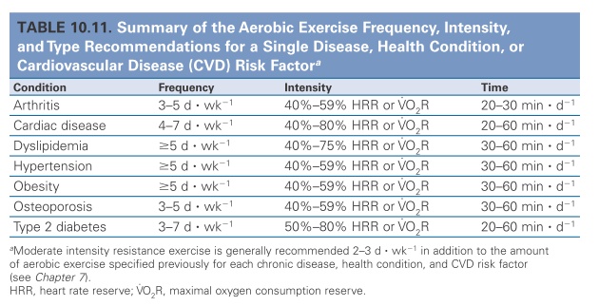

On page 344, advice is given regarding appropriate ways to determine an ideal exercise prescription in the presence of multiple comorbidities:

1. Identify the single disease and health condition that confers the greatest risk to your patient and/or is the most debilitating or limiting in activities of daily living, initiating and/or maintaining an exercise program. At this time, a discussion of your patient’s preferences and goals should also be facilitated.
2. A second approach would be to choose the most conservative ExRx for one of your patient’s multiple diseases, conditions and/or CVD risk factors found in Table 10.11.
3. Lastly, knowing the magnitude and time course of the expected results or responses from the initial FITT components of ExRx will aid in gauging appropriate progression while maintaining patient safety. Always monitor signs and symptoms to ensure safety, proper adaptation and progression of your patient.

Given the present case study, the condition that confers the greatest risk to her health is her HIV. She also smokes, leads a sedentary lifestyle, and has arthritis, which may be present challenges in her initiation and maintenance of an exercise program.

After considering all of this patient’s health conditions (and other important factors, such as performance in the HFRL fitness battery), her exercise prescription will be based on the HIV recommendations provided in chapter 10 (pages 294-295):

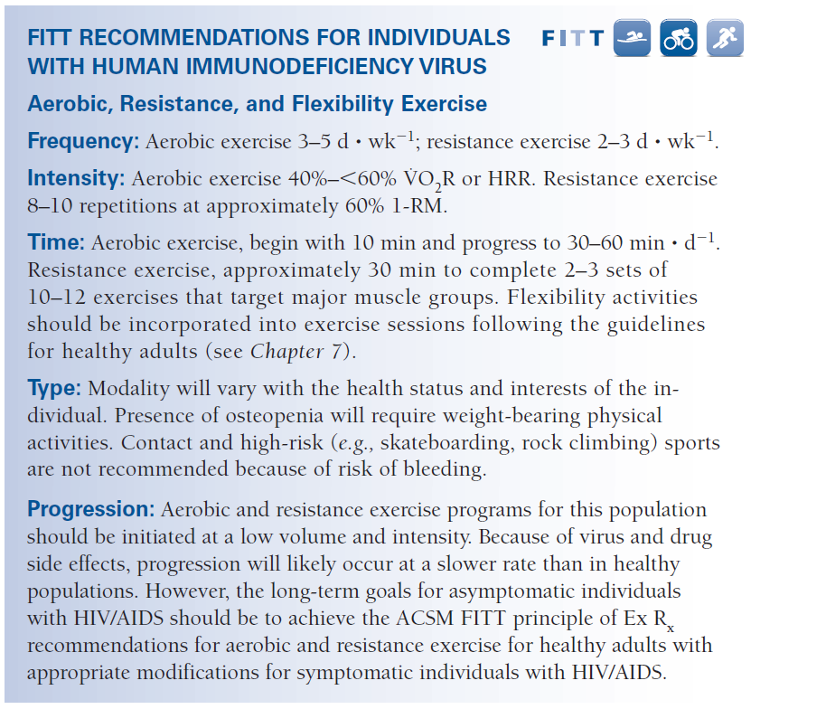

Before discussing the patient-specific modifications of this program, it must be acknowledged that the patient’s personal goals, expectations, interests, and aversions must be considered. An exercise prescription that isn’t followed is not a successful strategy to improve one’s health. Having said that, and having no ability to discuss these matters with the patient, I will proceed as though her interests are wholly compatible with my recommendations.

Regarding my recommendations for patient-specific modifications of the HIV prescription, I would make improvement of cardiopulmonary health a primary goal. Since her strength and physical functioning already appear adequate, but her cycle ergometer and resting heart rate measures indicate very poor cardiopulmonary health, improving those faculties will be the primary target on which her program will remain focused.

However, further modifications will be made to her program to accommodate her type 2 DM, as this also confers a considerable risk to her health. Pages 281-282 provided the ExRx for DM:

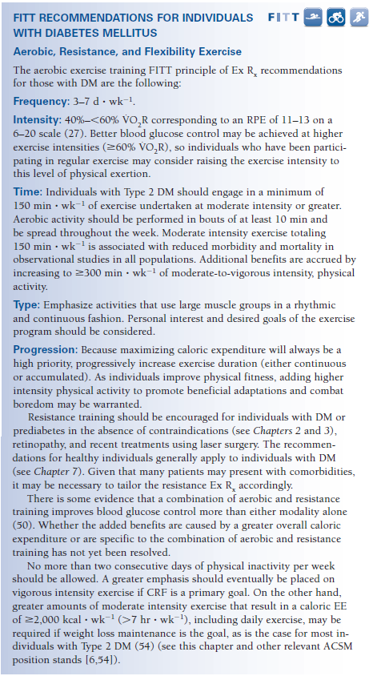

**Frequency.** The initial phase of her progression would adhere to the HIV recommendations, including aerobic exercise 3-5 days/week, and resistance exercise 2-3 days/week. As I stated earlier, the primary focus would be the aerobic exercise. If she is to be more adherent to one than the other, that is the mode of exercise I would stress as initially more important.

**Intensity.** In the initial phase of her progression, aerobic exercise will be done at a moderate intensity (40% to <60% VO2R or HRR and resistance exercise will be conducted at approximately 60% 1-RM for 8-10 repetitions per set, providing she is capable.

*GETP9* (pg. 31) indicates that physically unfit individuals should begin with light to moderate intensity and progress as their fitness improves. The importance of this precaution is that the risk for sudden cardiac death (or acute myocardial infarction) is greatest in people who perform vigorous intensity physical activity when they are unaccustomed to such activities. In contrast, the risk of a cardiac event during light to moderate intensity activity is equal to the risk experienced at rest. For this reason, light to moderate intensities (again, <60% VO2R or HRR) will comprise the initial prescription for intensity.

**Time.** As per the recommendations in the HIV FITT, the initial phase will involve bouts of aerobic exercise conducted in 10 min increments, eventually progressing to 30-60 min/day. Resistance exercise will be conducted over approximately 30 min, completing 2-3 sets per exercise during that time. She already exhibits good flexibility, so the guidelines for healthy adults will be suggested (2-3 days/week, holding each stretch 30-60 s; details provided in Table 7.7 on page 188). However, the flexibility/stretching guidelines will not be suggested at the *expense* of her focus on cardiopulmonary improvement. If time spent stretching would detract from time spent in aerobic exercise, the latter will be stressed while the former is only encouraged.

**Type.** The modality will vary with her interests and the state of her HIV (as well as other chronic health conditions). Specific accommodations made throughout the course of the exercise prescription are likely to be necessary in response to day-to-day variations in the subject’s condition.

In the FITT for DM, there is an emphasis on exercises and activities that use large muscle groups, while resistance exercise is encouraged among individuals without contraindications. I would not be inclined to initiate her program with such demanding exercises, but would test her capacity to tolerate them as tolerance appeared probable. During this time, the mode of exercise would have to be closely monitored to ensure particular exercises don’t exacerbate any symptoms (e.g., arthritis). If a specific exercise does, we will explore what is causing the flare up. Is it just the *amount* of exercise, or is it the specific type? For example, if we’re doing an incline treadmill, do the mechanics of the gait cause more pain than would a cycle ergometer? Or perhaps does the impact of the treadmill induce more discomfort than would an elliptical machine or laps in a pool?

Lastly, regarding type, because this HAPI patient reports sedentary behavior, the approach I will take in prescribing exercise will be to encourage any activity that will get her moving (out of bed, out of the chair, perhaps out of the house), emphasizing the importance of breaking up long periods of inactivity. Especially early on, before habits are established, the specific exercises and activities should reflect those that she enjoys and are accessible. Avoiding possible barriers to exercise (e.g., gym access, a lack of interest in a particular pursuit, etc.) are important early on in the program to increase exercise adherence.

**Volume.** Most of the initial volume will result from frequency and time, rather than intensity. Later in her progression, intensity will contribute to the total volume of exercise.

**Progression.**  The initiation of her exercise prescription will be at a low volume and an especially low intensity (not to exceed moderate). Due to the viral and pharmacological issues present, her progression will likely occur much slower than a typical healthy adult. However, the ultimate goal will be to progress her to such a level that she’s able to meet the ACSM FITT principles for healthy adults.

Regarding the expectation of progress, according to Spence et al. (1990), 6 weeks is enough time for resistance exercise to result in statistically significant improvements in strength. According to Stringer et al. (1998), 6 weeks is sufficient time to achieve significant cardiopulmonary improvements via aerobic exercise.

Although the progression of our exercise prescription would begin more conservatively than Stringer et al. and Spence et al. Their studies only lasted 6 weeks whereas the active duration in HAPI lasts 16 weeks, leaving us 10 additional weeks to change the mode of exercise and increase the intensity without posing undue risk to the patient.

During the initial phase of her progression, I will closely monitor how she responds to the transition into exercise, however mild. If this does not exacerbate her asthma, arthritis, or an unforeseen complication with her HIV, the volume could be increased accordingly, with frequency and time bearing that increase prior intensity.

As she proves capable (no contraindications, continued interest, progress is being made at an expected rate, etc.), I would attempt to progress her toward the volume suggested for type 2 DM (3-7 days a week with a minimum of 150 min per week of moderate intensity activity and no more than 2 consecutive days of physical inactivity allowed).

If these increases are tolerated well, intensity will follow. Although moderate intensity aerobic exercise will be safer and better tolerated initially, in time, more vigorous intensities may be prescribed (>60% VO2R) as higher intensities are associated with better glucose control (see DM FITT prescription). However, this will not come until much later in the progression and prior to engaging in vigorous intensity activity, it would be prudent to consult with a physician (as per Table 2.2 and figure 2.3) and to do so via a slow progression (as per recommendations in Chapter 10 of GETP9, pg. 342).