**The Influence of the Blood Lipid-Lipoprotein Profile on Psychological Well Being**

**Introduction**

Cholesterol is an organic steroid alcohol abundant in mammalian cell membranes (Saher et al., 2005). In addition to maintaining cell structures, cholesterol modulates the cell’s permeability (Yeagle, 1991), facilitates intracellular transport (Maxfield & Wüstner, 2002), has been implicated in cell signaling cascades (Ramprasad et al., 2007), is a biochemical precursor in the synthesis of compounds such as bile, vitamin D, and steroid hormones (Berg at al., 2002), and is critical to nerve conduction (Saher et al., 2005).

Although cholesterol is clearly appropriated for use in a variety of biological systems, its concentration in the central nervous system (CNS) is higher than that of any other human tissue, with 23% of the whole body pool residing there (Dietschy & Turley, 2004). The specific CNS tissue in which cholesterol is most concentrated is the myelin. 70% of the dry weight of myelin is composed of lipids, with cholesterol constituting more than 25% of that mass, relative to less than 20% of other plasma membranes (Morell & Jurevics, 1996).

When cholesterol was found to have such a robust presence in the CNS, it was arraigned by neuroscientists and physiologists alike for its potential role in phenomena beyond cardiovascular disease (CVD). Researchers began to examine the possible involvement of plasma cholesterol in the maturation of the childhood brain as well as its influence upon psychological wellbeing in the mature brain (Dietschy & Turley, 2004).

Among adults, the findings that link plasma cholesterol to measures of psychological wellbeing have been contradictory and inconclusive. Assessing total cholesterol (TC), Steegmans et al. (2000) found a positive relationship with psychological well being, Ledochowski et al. (2003) found a negative relationship, and Brown et al. (1994) found no correlation at all. Moreover, these inconsistencies are not new. In 1969, Jenkins et al. found elevated TC to be associated with positive personality traits whereas Oxenkrug et al. (1983) found no correlation between TC and emotional states.

This ongoing lack of concurrence can be partly attributed to the lack of an established definition of “psychological wellbeing.” While the sum of human flourishing encompasses more than the mere absence of disease, mental health research often fails to integrate this breadth. Wellbeing is frequently expressed as a vague sense of life satisfaction estimated through self-report questionnaires that assess the severity of negative mood states such as aggression, anxiety, and depression (Steegmans et al., 2000; Suls & Bunde, 2005; Virkkunen & Penttinen, 1984). At present, depression remains the most common indicator of wellbeing as it relates to cholesterol levels; one reason being its more refined diagnostic criteria (Kramek et al., 2010; APA, 2000).

In response to the incomplete and often vacillating definition, organizations such as the National Institute of Mental Health (NIMH) have positioned themselves as arbiters of the question: what is psychological wellbeing? The NIMH (2012) proposed a more accurate answer would incorporate one’s happiness or depression, anxiety, general hostility, stress levels, various expressions of mood, and inclinations toward aggression (NIMH, 2012). While this system of classification remains imprecise, it’s a constructive movement toward encompassing more of the central tenets of human flourishing.

Despite this effort, several researchers have jettisoned the subjective approach entirely, attempting to link TC with objective outcomes such as suicide attempts (Olié et al., 2011) and incidence of violent crime (Golomb, 1998). Others have investigated the relationship between TC and a predisposition for cognitive decline (Anstey et al., 2008) as well as various measures of intelligence such as abstract reasoning and concentration (Elias et al., 2005).

Although cholesterol’s role in each of these lacks a consistent verdict, the data do show apparent trends. Numerous researchers have found low levels of TC to associate with elevated risk of suicide (Engelberg, 1992; Garland et al., 2000; Kunugia et al., 1995; Olié et al., 2011) while fewer have found no correlation (Pekkanen et al., 1989; Smith et al., 1990). Most studies support the association between low TC levels and increased participation in violent crime (Golomb et al., 2000; Jacobs et al., 1992) while fewer have found no correlation (Cummings & Psaty, 1994; New, et al., 1999). Anstey et al. (2008) found high midlife TC to associate with an elevated risk of Alzheimer’s among 14,331 subjects, while Tan et al. (2003) found no associations among 5,209 subjects. And the findings among measures of intelligence vary wildly depending on gender and the tests administered (Benton, 1995; Muldoon et al., 1997), but typically support a positive relationship between TC and cognitive performance (Elias et al., 2005).

Other researchers have looked beyond TC, instead assessing the different components of the blood lipid-lipoprotein profile: high-density lipoproteins (HDL), low-density lipoproteins (LDL), and triglycerides. Much like the previous findings, these tend to be characterized more by inconsistency than accord.

Olusi & Fido (1996) reported a negative relationship between HDL levels and psychological wellbeing while Lehto et al. (2010) and Koponen et al. (2008) both reported positive relationships. With LDL levels, Strick et al. (2002) reported a positive relationship with psychological wellbeing while Muldoon et al. (2000) reported no relationship at all.

Plasma triglyceride levels appear to be the only variable unattached to a debate. Three studies (Elovanio et al., 2010; Fowkes et al., 1992; Glueck et al., 1993) have found elevated triglycerides to correlate with reduced psychological well being. There appears to be no finding that suggests the opposite. One potential explanation is the association with triglycerides and obesity, and in turn, obesity with depression (Elovanio et al., 2010). Another explanation was proposed by Stoney et al. (2002), who found acute psychological distress to reduce plasma clearance of triglycerides.

A possible mechanism to explain associations between TC and psychological wellbeing is through alterations in the transmission of serotonin (Chattopadhyay et al., 2007), a mood-enhancing neurotransmitter (Young, 2007). Low serum levels of TC appear to reduce the availability of free cholesterol surrounding the serotonin receptors. Such a reduction would precipitate an increase in the fluidity of the lipid membranes, which would in turn affect the brain’s ability to metabolize the neurotransmitter (Engelberg, 1992). The consequent reduction in serotonin levels would likely correspond to depression, aggressive tendencies, and an elevated risk of suicide (Steegmans et al., 2000).

The present study assessed whether there was an association between the blood lipid-lipoprotein profile and psychological well being among a large sample of healthy men (n=74) and women (n=73) age 20-76 yr. To evaluate this relationship, the entire blood lipid-lipoprotein profile was compared to a general measure of psychological well being as well as a specific assessment of depression. The results of this study are intended to provide researchers and clinicians with helpful information concerning the prevention, diagnosis and treatment of dyslipidemia and poor psychological wellbeing.

**Methods**

The data presented are a subset of a larger NIH funded study titled “The Effects of Statins on Muscle Performance” (STOMP) (NIH R01HL081893-01A2). Data collection for STOMP took place at University of Massachusetts, Amherst, MA, University of Connecticut, Storrs, CT, and Hartford Hospital, Hartford, CT. The experimental design was approved by the institutional review boards of all three test sites. STOMP was a double-blind investigation of the effects of statins on skeletal muscle performance and incidence of muscle pain (Thompson et al., 2010).

*Subjects*

The STOMP study recruited 220 men and 220 women, divided into equal age groups of 20-39, 40-54, and 55+ yr. Participants were healthy as determined by a set of inclusion/exclusion criteria. Individuals on antihypertensive medication were included providing they had adhered to their prescription for a minimum of 3 months and had a stable blood pressure. Subjects were excluded if they had been diagnosed with cancer in the last 5 yr, coronary artery disease, peripheral vascular disease, hyperthyroidism, hypothyroidism, diabetes, or renal disease. Any subject who was presently on or had previously been treated with lipid lowering medications was excluded. Exclusion criteria also extend to any subjects physically incapable of performing the muscle strength or aerobic testing protocols (Thompson et al., 2010).

*Study Procedures*

Subjects assigned to the experimental group were given 80 mg of daily Atorvastatin (Lipitor) while subjects assigned to the control group were given a placebo.

All subjects visited the laboratory 6 times over approximately 6 months. Subjects were asked to fast for 12 h prior to each visit excluding the fourth.

On the first visit (V1), fasted blood samples were drawn from the antecubital vein for determination of blood lipids-lipoproteins. Subjects also completed a series of questionnaires: a physical activity questionnaire, 2 surveys assessing the severity of myalgia and muscle symptoms, a depression inventory, and a general well being index. Lastly, subjects underwent a physical examination consisting of cardiorespiratory testing and several modes of strength assessment. A physician-supervised Bruce Protocol was employed for cardiorespiratory testing with VO2 max determined using a Parvomedics TrueOne 2400 metabolic cart (ParvoMedics Corp, Sandy, UT) and a breath-by-breath method. Strength was assessed through hand grip strength on a Jamar hand dynamometer (Sammons Preston, Inc. Bolingbrook,. IL. ABD, 60440-4989) and isometric and isokinetic strength measured on the dominant elbow and knee using a Biodex System 4 Pro isokinetic dynamometer (Biodex Medical Systems, Inc., Shirley, NY) (Thompson et al., 2010).

The second visit (V2) occurred at least 72 hr after V1. The same cardiorespiratory and strength assessment was completed. Subjects were also given an Actical accelerometer (Mini Mitter Company, Bend, OR, USA) and instructed to wear it for 4 consecutive days (2 week days and 2 weekend days). The third visit (V3) occurred at least 96 hr after V2 and the subjects once again underwent the strength assessment protocol. During V3, the subjects were randomized into the experimental or control groups and given a 3-month supply of either Atorvastatin or placebo. During the fourth visit (V4) a non-fasted blood sample was collected and another 3-month supply of Atorvastatin or placebo was distributed. The fifth visit (V5) took place 3 months later, during which subjects were asked to provide another 12 hr fasted blood sample and all strength and cardiorespiratory fitness tests were conducted. The subjects were also provided with Actical accelerometers and asked to repeat the 4-day protocol. The final visit (V6) occurred at least 96 hr after V5. The accelerometer data were collected and the final series of strength tests were performed.

*Sub-study Procedures*

This sub-study aims to answer a question the larger study was not designed to address: the influence of one’s fasted blood lipid-lipoprotein profile on psychological well being.

To answer this question, the entire blood lipid-lipoprotein profile was compared to the 2 questionnaires employed to assess psychological well being prior to the administration of either Atorvastatin or placebo. Both questionnaires have been validated in previous studies (NIMH, 2012) and are widely used tools to assess depression (Contreras et al., 2004) and general psychological well being (Wenger et al., 1984). All of the information used in this sub-study is based on data collected at V1.

*Lipid Profile*: Blood samples were drawn from the antecubital vein with a 21-gauge butterfly needle using a 4.0 mL lithium heparin tube for lipid-lipoprotein determinations. Samples were spun in a centrifuge (VanGuard V6500, Hamilton Bell Co., Inc., Montvale, NJ, USA) at 3400 RPM for 15 minutes. Plasma was then aliquated into 1.0 mL criovials and stored at -80 degrees until unbinding. Frozen samples were sent to Clinical Lab Partners (Hartford, CT) for analysis of total cholesterol, HDL cholesterol, and triglycerides. Low density lipoprotein (LDL) was later calculated with the Friedwald equation (Freidwald et al., 1972).

*Beck Depression Inventory (BDI)*: The BDI, completed during V1, is a 21 question, multiple choice assessment of the severity of depression (Beck et al., 1961; Beck et al., 1979). Each item on the assessment relates to a different symptom of depression: 1) mood, 2) pessimism, 3) sense of failure, 4) lack of satisfaction, 5) guilt, 6) sense of punishment, 7) self-dislike, 8) self-criticism, 9) thoughts of suicide, 10) crying, 11) irritability, 12) social withdrawal, 13) indecisiveness, 14) distortion of body image, 15) work inhibition, 16) changes in sleeping patterns, 17) fatigability, 18) changes in appetite, 19) weight loss, 20) somatic preoccupation, and 21) loss of sexual interest (Beck et al., 1988). Each of these items receives a score between 0 and 3. These are added together to form a composite score ranging from 0-63, with higher scores indicating more severe depression. A score of 0-9 indicates minimal depression, 10-18 indicates mild depression, 19-29 indicates moderate depression, and 30-63 indicates severe depression (Beck et al., 1988). Others such as Kramek et al. (2010) use different cutoffs: 0-13 indicates minimal depression, 14-19 indicates mild depression, 20-28 is moderate depression, and 29-63 is severe depression. However, these cutoffs appear to be selected arbitrarily while those published by Beck et al. (1988) are based on clinical reports by the Center for Cognitive Therapy. We therefore use the cutoffs provided by Beck et al. (1988).

*Psychological General Well Being Index (PGWBI)*: The PGWBI, also completed during V1, is a 22-question multiple choice assessment of one’s general well being (Dupuy 1984). It encompasses 6 domains: 1) anxiety, 2) depressed mood, 3) positive wellbeing, 4) self-control, 5) general health, and 6) vitality (Revicki et al., 1996). Each question receives a score of 0-5. The total score ranges from 0-110 with higher scores indicating greater psychological well being. Scores of 0-60 represent severe psychological distress, scores of 61-72 represent moderate distress, and scores of 73-110 represent positive wellbeing (Chassany et al., 2004). Other researchers such as Grossi et al. (2011) have used index scores of >85 to indicate general psychological well being while scores <70 represent psychological distress. These scores appear to originate with a conference presentation by Sacco et al. (2009), who appear to have chosen them without a sufficient rationale. Contrasting this, the former index scores come from the PGWBI User Manual (Chassany et al., 2004) and are the result of intensive analyses among tens of thousands of men and women from a variety of countries across a broad age group. We therefore use these index values.

*Statistical Analysis*

STOMP data were compiled in an online database at Hartford Hospital. All analyses were done using the Statistical Package for the Social Sciences Base (SPSS) 14.0 for Windows (SPSS Inc, Chicago, IL) and statistical significance was set at p<0.05. Descriptive statistics were used to portray the mean values for all variables, represented as mean ± standard deviation (Mean ± SD). The general characteristics between genders were compared with an independent sample t test. Pearson product moment correlation coefficients were calculated to examine the relationship between components of the blood lipid-lipoprotein profile (mg/dL) and scores on the BDI and PGWBI. Multivariate regressions were used to examine if age, gender, season, and waist circumference influenced the relationships among components of the blood lipid-lipoprotein profile and psychological well being.

**Results**

Table 1 displays the subjects’ physical and mental health characteristics. The sample of this sub-study (n=147) consisted of healthy men (n=74) and women (n=73). Subjects were slightly overweight, yet had near optimal total cholesterol and LDL cholesterol levels as well as optimal triglyceride levels. The population also exhibited a high HDL cholesterol level. Women had a significantly higher total (p<0.05) and HDL cholesterol (p<0.001) compared to men. However, men had a larger waist circumference (p<0.001), higher BMI (p<0.05), triglyceride levels (p<0.01), Trig/HDL ratio (p<0.001), and SBP (p<0.05) than the women. Mean values of the BDI and PGWBI are indicative of minimal depression and a positive state of well being. The scores were not different between men and women (Table 1).

DDI validation: Hamilton psychiatric rating scale for depression.

PGWBI: EuroQoL 5q-ed. Severity of disease states like diabetes also

used, but this is nonsense. It’s been shown in study after study that

people of comparable states of wealth and health and luck have vastly

different subjective QOL.

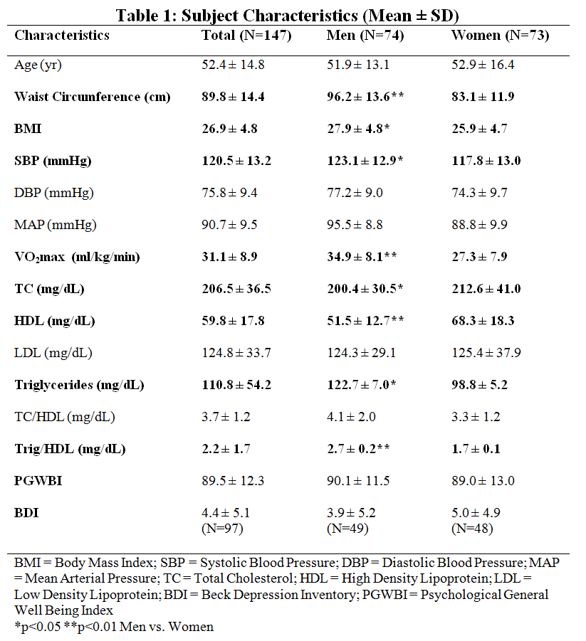

*Beck Depression Inventory*

BDI data were collected on 97 subjects, of which 89 (92%) had minimal depression, 6 were mildly depressed, 1 was qualified with moderate depression, and 1 was considered severely depressed. Figure 1 illustrates the distribution of values.

**Figure 1: Pie chart and bar graph illustrating the distribution of BDI values**

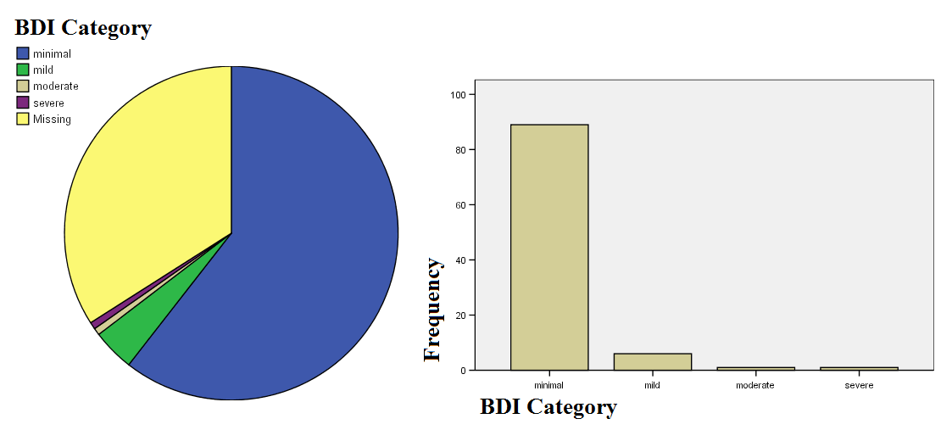

For continuous BDI score: General linear model. Univariate. Gender as a fixed factor. Age, BMI, TC, HDL, LDL, and triglycerides as covariates.



Logistic regression (for predicting outcome of a categorical dependent variable from continuous independent variable). Binary for 2 outcomes. Multinomial for more than 2.

Table 2 shows the relationship among components of the blood lipid-lipoprotein profile and BDI score. No significant correlation was found between the BDI and any component of the blood lipid-lipoprotein profile. Gender (β =0.211, r2=0.043, p=0.038) and BDI (β =0.142, r2=0.020, p=0.158) were able to account for 5.1% of the variance in total cholesterol levels. In addition, gender (β =0.266, r2=0.078, p=0.007), waist circumference (β =0.404, r2=0.166, p<0.001) and BDI (β = -0.037, r2=0.002, p=0.671) accounted for 30% of the variance in HDL cholesterol levels. A small proportion of the variance in LDL cholesterol (4.7%) was explained by age (β =0.207, r2=0.043, p=0.040) and BDI (β =0.153, r2=0.023, p=0.128). Two factors, waist circumference (β =0.416, r2=0.174, p<0.001) and BDI (β =0.100, r2=0.012, p=0.291) accounted for 17% of the variance seen in triglycerides. The same two factors, waist circumference (β =0.469, r2=0.223, p<0.001) and BDI (β =0.081, r2=0.008, p=0.380), explained 21% of the variance in the triglyceride/HDL ratio. (Table 2).

TABLE 2

*Psychological General Well Being Index:*

PGWBI data were collected on 147 subjects, of which 132 (90%) had positive wellbeing, 11 were under moderate distress, and 1 was qualified as severely distressed. Figure 2 illustrates the distribution of values.

**Figure 2: Pie chart and bar graph illustrating the distribution of PGWBI values**

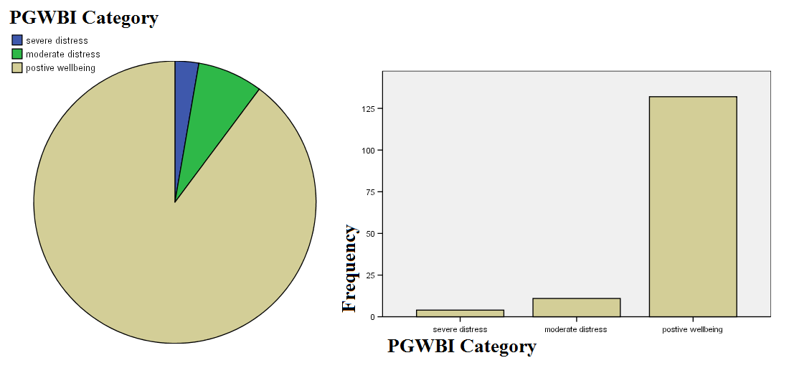

Table 3 displays the relationship among components of the blood lipid-lipoprotein profile and score on the Psychological General Well Being Index. No significant correlation was found between the PGWBI and any of the blood lipid-lipoprotein profile components (Table 3). A small proportion of the variance in total cholesterol (8.4%) was explained by gender (β =0.161, r2=0.028, p=0.044), age (β =0.271, r2=0.076, p=0.001), and PGWBI score (β =0.042, r2=0.002, p=0.593). Three factors explained 28% of the variance in HDL cholesterol scores; gender (β =0.329, r2=0.106, p<0.001), waist circumference (β = -0.310, r2=0.075, p<0.001) and PGWBI (β =0.033, r2=0.002, p=0.648). Age (β =0.338, r2=0.114, p<0.001) and PGWBI (β =0.030, r2=0.001, p=0.703) accounted for 10% of the variance in LDL cholesterol. Waist circumference (β =0.392, r2=0.152, p<0.001) and PGWBI (β =0.004, r2=0.000, p=0.956) were able to explain 14% of the variance in triglyceride levels. The same two factors, waist circumference (β =0.399, r2=0.158, p<0.001) and PGWBI (β = -0.006, r2=0.000, p=0.941) accounted for 15% of the variance in the triglyceride/HDL ratio. (Table 3).

TABLE 3

**Sources**

American Psychiatric Association. (2000). Diagnostic and statistical manual of mental disorders (4th ed., text rev.). Washington, DC.

Anstey, K. J., Lipnicki, D. M., & Low, L. F. (2008). Cholesterol as a risk factor for dementia and cognitive decline: a systematic review of prospective studies with meta-analysis. American Journal of Geriatric Psychiatry, 16(5): 343–54.

Beck, A. T., Rush, A. J., Shaw, B. F., & Emery, G. (1979). Cognitive therapy of depression. New York: Guilford Press.

Beck, A. T., Steer, R. A., & Carbin, M. G. (1988). Psychometric properties of the Beck Depression Inventory: Twenty-five years of evaluation. Clinical Psychology Review, 8(1): 77-100.

Beck, A. T., Ward, C. H., Mendelson, M., Mock, J. & Erbaugh J. (1961). An Inventory for Measuring Depression. Archives of General Psychiatry, 4: 561–571.

Benton, D. (1995). Do low cholesterol levels slow mental processing? Psychosomatic Medicine, 57(1): 50–53.

Berg, J. M., Tymoczko, J. L., & Stryer L. (2002). Biochemistry. 5th edition. New York: W H Freeman; Section 26.4, Important Derivatives of Cholesterol Include Bile Salts and Steroid Hormones. Available online: http://www.ncbi.nlm.nih.gov/books/NBK22339/, retrieved 17june2012.

Brown, S. L., Salive, M. E., Harris, T. B., Simonsick, E. M., Guralnik, J. M., & Kohout, F. J. (1994). Low Cholesterol Concentrations and Severe Depressive Symptoms in Elderly People. BMJ, 308(6940): 1328–1332.

Chassany, O., Dimenas, E., Dubois, D., Wu, A., & Dupuy, H.(2004). The Psychological General Well-Being Index (PGWBI) User Manual. MAPI Research Institute, Lyon, France.

Chattopadhyay, A., Paila, Y. D., Jafurulla, M., Chaudhuri, A., Singh, P., Murty, M. R., & Vairamani, M. (2007). Differential effects of cholesterol and 7-dehydrocholesterol on ligand binding of solubilized hippocampal serotonin1A receptors: Implications in SLOS. Biochemical and Biophysical Research Communications, 363(3): 800-805.

Contreras, S., Fernandez, S., Malcarne, V., Ingram, R., & Vaccarino, V. (2004). Reliability and Validity of the Beck Depression and Anxiety Inventories in Caucasian Americans and Latinos. Hispanic Journal of Behavioral Sciences 26(4), 446-462.

Cummings, P. & Psaty, B. M. (1994). The association between cholesterol and death from injury. Annals of Internal Medicine, 120(10): 848–855.

Dupuy, H. J. (1984). The Psychological General Well Being (PGWB) Index. In Wenger, NK, Mattson, ME, Furberg, CD & Elinson, J (Eds.). Assessment of Quality of Life in Clinical Trials of Cardiovascular Therapies. pp. 170-183. New York, NY: Le Jacq.

Dietschy, J. M. & Turley, S. D. (2004). Thematic review series: brain Lipids. Cholesterol metabolism in the central nervous system during early development and in the mature animal. Journal of Lipid Research, 45(8): 1375–1397.

Dupuy, H. J. (1984). The Psychological General Well Being (PGWB) Index. In Wenger, NK, Mattson, ME, Furberg, CD & Elinson, J (Eds.). *Assessment of Quality of Life in Clinical Trials of Cardiovascular Therapies.* pp. 170-183. New York, NY: Le Jacq.

Elias, P. K., Elias, M. F., D’Agostino, R. B., Sullivan, L. M., & Wolf, P. A. (2005). Serum Cholesterol and Cognitive Performance in the Framingham Heart Study. Psychosomatic Medicine, 67(1): 24–30.

Elovainio, M., Pulkki-Råback, L., Kivimäki, M., Jokela, M., Viikari, J., Raitakari, O. T., & Keltikangas-Järvinen, L. (2010). Lipid trajectories as predictors of depressive symptoms: The young finns study. Health Psychology, 29(3): 237–245.

Engelberg, H. (1992). Low serum cholesterol and suicide. The Lancet, 339(8795): 727–729.

Fowkes, F. G. R., Leng, G. C., Donnan P. T., Housley, E., Deary, I. J., & Riemersma, R. A. (1992). Serum cholesterol, triglycerides, and aggression in the general population. The Lancet, 340(8826): 995–998.

Freidwald, E. T., Levy, R. I., & Fredickson, D. S. (1972). Estimation of the concentration of low density lipoproteins by a simple precipitation procedure. *Clin Chem*, 18: 499-502.

Garland, M., Hickey, D., Corvin, A., Golden, J., Fitzpatrick. P., Cunningham, S., & Walsh, N. (2000). Total serum cholesterol in relation to psychological correlates in parasuicide. British Journal of Psychiatry, 177: 77–83.

Glueck, C. J., Tieger, M., Kunkel, R., Tracy, T., Speirs, J., Streicher, P., Illiq, E. (1993). Improvements in Symptoms of Depression and in an Index of Life Stressors Accompany Treatment of Severe Hypertriglyceridemia. Biological Psychiatry, 34(4): 240–52.

Golomb, B. A. (1998). Cholesterol and violence: is there a connection? Ann. Intern. Med. 128: 478–487.

Golomb, B. A., Stattin, H., & Mednick, S. (2000). Low cholesterol and violent crime. Journal of Psychiatric Research, 34: 301–309.

Grossi, E., Blessi, G. T., Sacco, P. L., & Buscema, M. (2011). The Interaction Between Culture, Health and Psychological Well-Being. Journal of Happiness Studies, 13(1): 129-148.

Jacobs, D., Blackburn, H., Higgins, M., Reed, D., Iso, H., McMillan, G., Neaton, J., Nelson, J., Potter, J., & Rifkind, B. (1992). Report of the Conference on Low Blood Cholesterol: Mortality Associations. Circulation, 86: 1046–1060.

Jenkins, C. D., Hames, C. G., Zyzanski, S. J., Resenman, R. H., & Friedman, M. (1969). Psychological Traits and Serum Lipids. I. Findings from the California Psychological Inventory. Psychosomatic Medicine, 31(2): 115-128.

Koponen, H., Jokelainen, J., Keinanen-Kiukaanniemi, S., Kumpusalo, E., & Vanhala, M. (2008). Metabolic syndrome predisposes to depressive symptoms: A population-based 7-year follow-up study. The Journal of Clinical Psychiatry, 69(2): 178–182.

Kramek, E., Jastrzebska, S., Walczak-Jedrzejowska, R., Marchlewska, K., Oszukowska, E., Guminska, A., Slowikowska-Hilczer, J. (2010). Blood lipids may have influence on the emotional well-being in young men. Health, 2(5), 441-447.

Kunugia, H., Takeia, N., Aokib, H., & Nankob, S. (1995). Low serum cholesterol in suicide attempters. Biological Psychiatry, 41(2): 196–200.

Ledochowski, M., Murr, C., Sperner-Unterweger, B., Neurauter, G., & Fuchs, D. (2003). Association between increased serum cholesterol and signs of depressive mood. Clinical Chemistry and Laboratory Medicine, 41(6): 821–824.

Lehto, S. M., Niskanen, L., Tolmunen, T., Hintikka, J., Viinamäki, H., Heiskanen, T., Honkalampi, K., Kokkonen, M., & Koivumaa-Honkanen, H. (2010). Low serum HDL-cholesterol levels are associated with long symptom duration in patients with major depressive disorder. Psychiatry and Clinical Neurosciences, 64(3):279–83.

Maxfield, F. & Wüstner, D. (2002). Intracellular cholesterol transport. Journal of Clinical Investigation, 110(7): 891–898.

Morell, P. & Jurevics, H. (1996). Origin of cholesterol in myelin. Neurochemical Research, 21(4): 463–470.

Muldoon, M. F., Barger, S. D., Ryan, C. M., Flory, J. D., Lehoczky, J. P., Matthews, K. A., & Manuck, S. B. (2000). Effects of lovastatin on cognitive function and psychological well-being. The American Journal of Medicine, 108(7): 538–546.

Muldoon, M. F., Ryan, C. M., Matthews, K. A., & Manuck, S. B. (1997). Serum cholesterol and intellectual performance. Psychosomatic Medicine, 59(4): 382–387.

New, A. S., Sevin, E. M., Mitropoulou, V., Reynolds, D., Novotny, S. L., Callahan, A.,Trestman R. L., & Siever, L. J. (1999) Serum cholesterol and impulsivity in personality disorders. Psychiatry Research, 85: 145–150.

National Institute of Mental Health (NIMH), www.nimh.nih.gov, retrieved 17june2012.

Olié, E., Picot, M. C., Guillaume, S., Abbar, M., & Courtet, P. (2011). Measurement of total serum cholesterol in the evaluation of suicidal risk. Journal of Affective Disorders, 133(1-2): 234–238.

Olusi, S. O. & Fido, A. A. (1996). Serum Lipid Concentrations in Patietns with Major Depressive Disorder. Society of Biological Psychiatry, 40(6): 1128–31.

Oxenkrug, G.F., Branconnier, R. J., Harto Truax, N., & Cole, J. O. (1983). Is serum cholesterol a biological marker for major depressive disorder? American Journal of Psychiatry, 140(7): 920–921.

Pekkanen, J., Nissinen, A., Punsar, S., & Karvonen, M. J. (1989): Serum cholesterol and risk of accidental or violent death in a 25-year follow-up: the Finnish cohorts of the seven countries study. Archives of Internal Medicine, 149: 1589–1591.

Ramprasad, O. G., Srinivas, G., Rao, K. S., Joshi, P., Thiery, J. P., Dufour, S., & Pande, G. (2007). Changes in cholesterol levels in the plasma membrane modulate cell signaling and regulate cell adhesion and migration on fibronectin. Cell Motility and the Cytoskeleton, 64(3): 199–216.

Revicki, D, Leidy, N, & Howland, L. (1996) Evaluating the Psychometric Characteristics of the Psychological General Well-Being Index with a New Response Scale. *Quality of Life Research,* 5(4): 419-425.

Sacco, P. L, Grossi, E., Cerutti, R., & Tavano Blessi, G. (2009). Culture and Well-Being: The role of cultural participation on low and high perceived psychological well-being. Quality of life studies: Measures and goals for the progress of the societies. International Conference, Florence, Italy, July 19–23.

Saher, G., Brügger, B., Lappe-Siefke, C., Möbius, W., Tozawa, R., Wehr, M., Wieland, F., Ishibashi, S., & Nave, K. (2005). High cholesterol level is essential for myelin membrane growth. Nature Neuroscience 8: 468–475.

Smith, G. D., Shipley, M. J., Marmot, P. G., & Patel, C. (1990). Lowering cholesterol concentrations and mortality. British Medical Journal, 301: 552.

Steegmans, P. H. A., Hoes, A. W., Bak, A. A. A., van der Does, E., & Grobbee, D. E. (2000). Higher Prevalence of Depressive Symptoms in Middle-Aged Men with Low Serum Cholesterol Levels. Psychosomatic Medicine, 62(2): 205–211.

Stoney, C. M., West, S. G., Hughes, J. W., Lentino, L. M., Finney, M. L., Falko, J. & Bausserman, L. (2002). Acute psychological stress reduces plasma triglyceride clearance. Psychophysiology, 39: 80–85.

Strick, J. J., Lousberg, R., Crijns, H. J., Maes, M., Honig, A. (2002) Relation of Levels of Serum Lipoproteins to Depression after Acute Myocardial Infarction. The American Journal of Cardiology, 90(12): 1368–70.

Suls, J. & Bunde, J. (2005). Anger, Anxiety, and Depression as Risk Factors for Cardiovascular Disease: The Problems and Implications of Overlapping Affective Dispositions. Psychological Bulletin.131(2): 260–300.

Tan, Z. S., Seshadri, S., Beiser, A., Wilson, P. W., Kiel, D. P., Tocco, M., D'Agostino, R. B., & Wolf PA. Plasma total cholesterol level as a risk factor for Alzheimer disease: the Framingham Study. Archives of Internal Medicine, 163(9): 1053–1057.

Thompson, P. D., Parker, B.A., Clarkson, P.M., Pescatello, L.S., White, M.C., Grimaldi, A.S., Levine, B.D., Haller, R.G., & Hoffman, E.P. (2010) A randomized clinical trial to assess the effect of statins on skeletal muscle function and performance: rationale and study design. *Preventative Cardiology*, 13(3): 104-111.

Virkkunen, M. & Penttinen, H. (1984). Serum cholesterol in aggressive conduct disorder: a preliminary study. *Biol. Psychiatry*, 19: 435–439.

Wenger, N.K., Mattson, M.E., Furberg, C.D., Elinson, J. eds. Assessment of quality of life in clinical trials of cardiovascular therapies. Greenwich, CT: Le Jacq Publishing, Inc, 1984; 170-183: 353-356.

Yeagle. (1991). Modulation of membrane function by cholesterol. *Biochimie*, 73(10): 1303–1310.

Young, S. N. (2007). How to increase serotonin in the human brain without drugs. Journal of Psychiatry and Neuroscience, 32(6): 394–399.